Made by 6188086 Kittikorn Keeratikriengkrai and 6188089 Nattawipa Saetae

Required:

1. Java Script
2. Node.js (or use Nodemon )
3. .Python
4. .Numpy (pip install numpy)

How to run the code.

1. Direct to the folder using cmd cd command

2. Run command "node <filename.js> <param> <param> ..."

1 unreliable_transmission

Or “python unreliable_transmission.py "1010100101" 30”

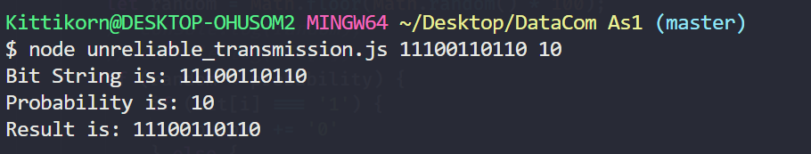

2 Parity bit

2.2.1 parity_gen

Use this command to run “python parity_gen.py "110010110" 3 3x3 “

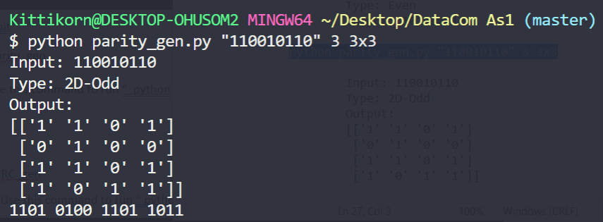

2.2.2 parity_check

Use this command to run “python parity_check.py "1101010011011011" 3 3x3 “

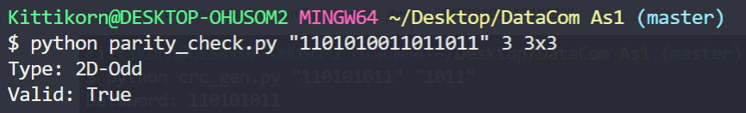

3 CRC

3.2.1 CRC_gen

Use this command to run “ python crc_gen.py "110101011" "1011"”

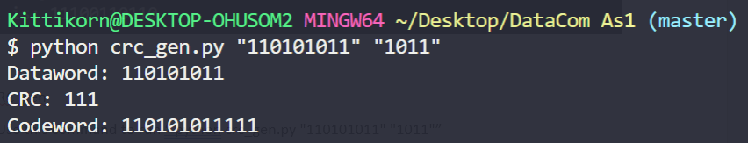

3.2.2 CRC_check

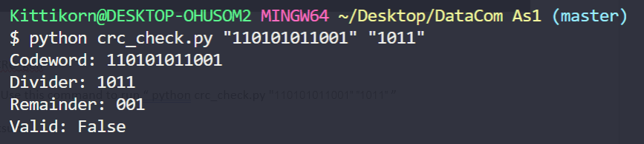 Use this command to run “ python crc_check.py "110101011001" "1011" ”

4.1Checksum

4.1.1 Checksum_gen

Use this command to run “node checksum_gen.js 1110001010101001 4 3”

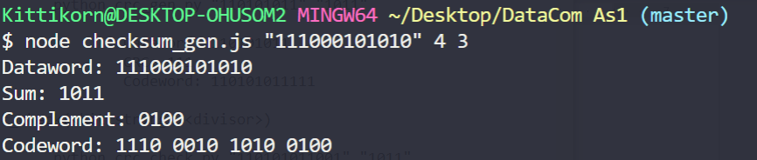

4.1.2 Checksum_check

Use this command to run “node checksum.js 1110001010101001 4 3”

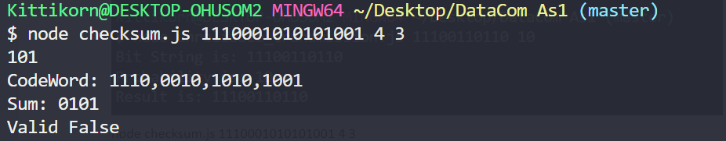

5 Hamming code

5.1.1 Hamming_gen

Use this command to run “python hamming_gen.py "11010101011"

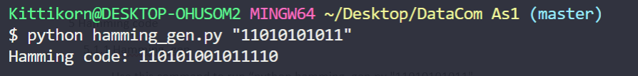

5.1.2 hamming_check

Use this command to run “python hamming_check.py "110101011011110"

